INDIAN SCHOOL ALWADI ALKABIR
DEPARTMENT OF SOCIAL SCIENCE
POST-MID TERM ASSESSMENT: 2023-24

CLASS: VII Max: Marks: 30 Date: 03.12.23 ANSWER KEY Time: 1Hour.
General Instructions: -
1. Ensure that you have written your name and roll number correctly.
2. This Question paper has three parts, Section A (History)B (Civics) C (Geography).
3. All questions are compulsory.
4. All the answers must be correctly numbered as in the question paper in the Answer sheet
provided
Q.No | SECTION - A (HISTORY) 10 Marks
I | Choose the correct option: - | 1 Mark
1 | Where did the Balochi tribes live during the Mughal rule?  (a) North West (b) North East (c) South East (d) South West | 1 Mark
II | Fill in the blanks: - | 2 Marks
2 | The __________ mentions that Garha Katanga had 70,000 villages.  Answer: Akbar Nama | 1 Mark
3 | Historical works called Buranjis were written in ________ and Ahom language.  Answer: Assamese | 1 Mark
III | Answer in one or two sentences: - | 2 Marks
4 | Which tribe was the most influential in Punjab during the 13th and 14th centuries?  Answer: In Punjab, the Khokhar tribe was the most influential during the 13th and 14th century. | 1 Mark
5 | What kind of exchanges took place between nomadic pastoralists and settled agriculturists?  Answer: The nomadic pastoralists exchanged wool, ghee, etc. with settled agriculturists for grain, cloth, utensils and other products | 1 Mark
IV | Answer the following questions: - | 2 Marks
6 | Observe the given picture and answer the following questions: -  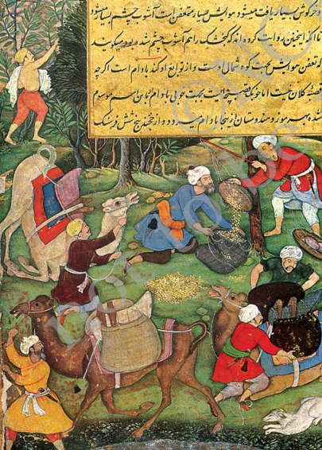  - Who brought the goods to India?  Answer: Central Asian traders bought the goods to India.  - Who carried the goods to the local markets?  Answer: Banjaras and other traders. | 2 Marks  1 Mark  1 Mark
V | Answer in detail: - | 3 Marks
7 | How was the administration of the Ahom state organized?  - The Ahom state depended upon forced labour. Those forced to work for the state were known as paiks.  - A census of the population was taken. Each village had to send a number of paiks by rotation.  - People of densely populated areas were shifted to thinly populated areas. Ahom clans were thus broken up.  By the first half of the 17th century the administration became quite centralized | 3 Marks
 | SECTION - B (CIVICS) 10 Marks
VI | Choose the correct option: - | 1 Mark
8 | Who becomes the Chief Minister?  (a) President of the country (b) Leader of losing party in Elections (c) Prime Minister of the country (d) Leader of the winning party in Elections | 1 Mark
VII | Fill in the blanks: - | 1 Mark
9 | The political party which lost in the Election play the role of __________.  Answer: Opposition | 1 Mark
VIII | Match the following : - | 2 Marks
10 | Agriculture Department a. Election | 1 Mark
11 | Himachal Pradesh b. irrigation and water resource projects | 1 Mark
 | c. 68 constituencies
 | ANS.10-b 11-c
IX | Answer in one or two sentences: - | 1 Mark
12 | Who appoints the Chief Minister of the State?  Ans: The Governor appoints the Chief Minister of the State | 1 Mark
X | Case Study Question: - | 2 Marks
13 | Read the following paragraph and answer the questions: -  The people in power like the chief minister and the minister have to take action. They do so through various departments like the Public Works Department, the Agriculture Department, the Health Department, the Education Department and so on. They also have to answer questions that are asked in the Legislative Assembly and convince people asking the questions that proper steps are being taken.  - What is the Role of the Legislative Assembly?  Answer: Role of the Legislative Assemblies is to answer questions that are asked in the Legislative Assembly and convince people asking the questions that proper steps are being taken.  - Who are responsible for taking decision in the government?  Answer: The People in power responsible for taking decision in the government include the Chief Minister and other Ministers. | 2 Marks  1 Mark  1 Mark
XI | Answer in detail: - | 3 Marks
14 | What are the powers and functions of the Chief Minister?  Answer. His powers are as follows: -  *The Chief Minister is the real head of the state government.  *He provides a list of ministers to governor. The Governor then appoints other ministers.  *He distributes portfolios among the ministers.  *He presides over the meetings of the cabinet.  * He maintains good relationship with the central government | 3 Marks
 | SECTION - C (GEOGRAPHY) 10 Marks
XII | Choose the Correct Option: - | 2 Marks
1 | The degree of hotness and coldness in the air is known as __________ (a) Temperature (b) Sea Level (c)Wind (d) Weather | 1 Mark
2 | The ozone layer is found in ______.  (a) Troposphere (b) Thermosphere (c) Mesosphere (d)Stratosphere. | 1 Mark
XIII | Fill in the blanks: - | 1 Mark
3 | ____________ is released in the air by burning the fuels.  Answer: Carbon dioxide. | 1 Mark
XIV | Match the following: - | 1 Mark
4 | Monsoon a) Permanent Wind | 1 Mark
 | b) Seasonal Wind
 | c) Horizontal movement of air
 | Answer: b) Seasonal Wind
XV | Answer in one or two sentences: - | 1 Mark
5 | What is ‘insolation’?  Answer: Insolation is the incoming solar energy intercepted by the earth | 1 Mark
XVI | Observe the diagram and answer the questions: -  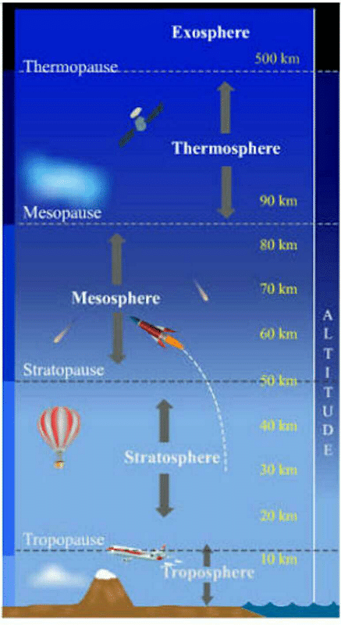  - Name the light gases that float into the space from Exosphere.  Answer: Light gases like helium and hydrogen.  - Name the layer in which Ionosphere is found.  Answer: Thermosphere. | 2 Marks  1 Mark  1 Mark
XVII | Answer in detail: - | 3 Marks
6 | Why does the amount of insolation decrease from equator towards poles?  Answer *Insolation comes through vertical rays on equator. Thus, it covers up less space but we feel more heat there when it goes up from equator towards poles, the sun rays become slanting.  *Needless to say that slanting rays come on the earth covering longer  distance.  *Although these slanting rays heat up more space, the degree of hotness is felt less. This is the reason why amount of insolation decreases from equator towards poles. | 3 Marks

